
Symbiosis Institute of Technology, Pune
Faculty of Engineering
CSE- Academic Year 2026-27
Java Programming – Lab Batch 2025-29
Lab Assignment No:- 18
Name of Student | Aarushi Raizada
PRN No. | 25070122002
Batch | 2025-29
Class | A1
Academic Year & Semester | 2026 Sem III
Date of Submission | 27th August’26
Title of Assignment: | Write a Java GUI program to demonstrate button click event handling.
Theory  Practice questions | Event handling allows Java programs to respond to user actions such as button clicks, mouse  movements, and keyboard input. Swing uses ActionListener to process button click events.  Event-driven programming separates user interface design from event-processing logic, making  applications interactive and user-friendly.  1. Create a GUI calculator where buttons perform addition and subtraction.  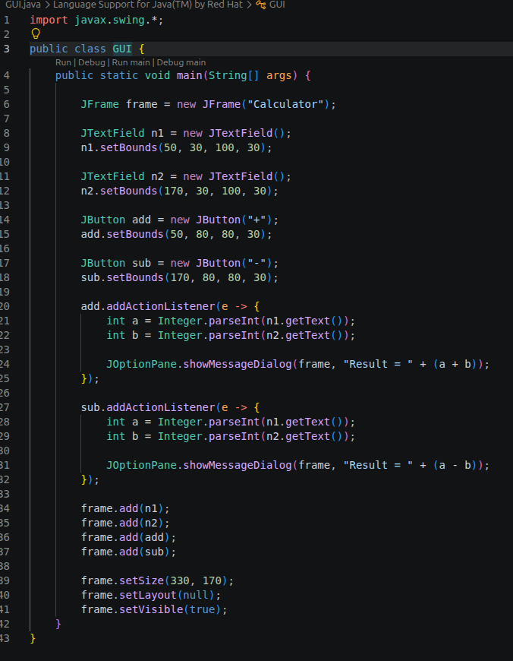  2. Create a Bank Balance Calculator GUI application using Java Swing where the user  enters the initial balance and transaction amount. Use buttons to perform addition (deposit)  and subtraction (withdrawal) and display the updated balance.  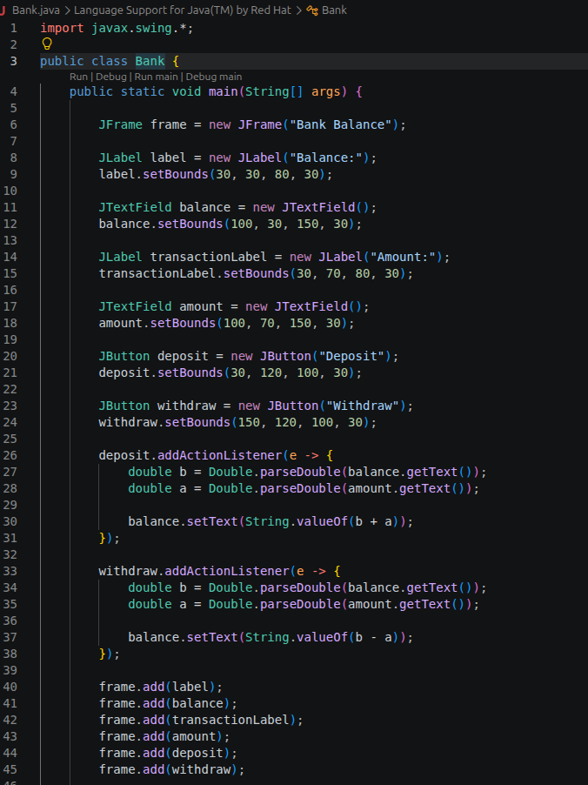  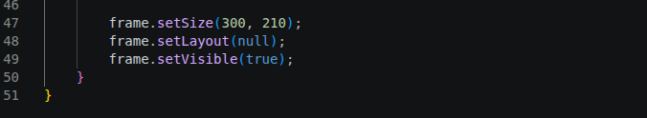
Output Screenshots (if applicable) | Ans 1  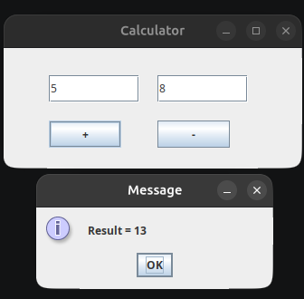  Ans 2  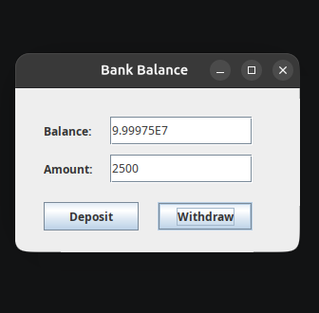
Conclusion | Thus, the Java GUI programs were successfully created using Swing and ActionListener. Button click events were handled to perform addition, subtraction, deposit, and withdrawal operations and display the required results.

